Add this in Copy Content
SERVICES CONTENT
COPY
Make an impact with compelling content that turns sound ideas into workable solutions, driving engagement and sales.
Services Offered: These services can help transform sound ideas into actionable content strategies that drive engagement and sales, ensuring a comprehensive approach to content marketing and copywriting.

Content Creation Services
- Blog Writing: Crafting engaging and informative blog posts that resonate with your target audience.
- Article Writing: Producing in-depth articles that establish authority in your industry.
- SEO Copywriting: Creating content optimized for search engines to drive organic traffic.
- Social Media Content: Developing shareable content for platforms like Facebook, Instagram, Twitter, and LinkedIn.
- Email Marketing: Writing compelling email copy that increases open rates and conversions.

Content Strategy Services
- Content Planning and Strategy: Developing a comprehensive content plan aligned with business goals.
- Editorial Calendar Management: Organizing and scheduling content to maintain a consistent publishing schedule.
- Audience Research: Identifying and understanding target audience demographics and preferences.
- Competitor Analysis: Analyzing competitors' content strategies to find gaps and opportunities.

Content Marketing Services
- Content Distribution: Ensuring content reaches the right audience through various channels.
- Influencer Outreach: Collaborating with influencers to amplify content reach.
- Guest Blogging: Writing and pitching guest posts to high-authority websites to expand audience reach.
- Webinar Content: Creating engaging scripts and presentations for webinars.

Multimedia Content Services
- Video Scriptwriting: Crafting scripts for promotional, explainer, and testimonial videos.
- Podcast Scripting and Production: Developing scripts and producing engaging podcast episodes.
- Infographic Design and Content: Creating visually appealing infographics to present data and ideas effectively.

Content Optimization Services
- Content Audits: Reviewing existing content to identify improvement areas and opportunities.
- A/B Testing: Conducting tests to determine the most effective content formats and headlines.
- Conversion Rate Optimization (CRO): Optimizing content to increase the conversion rate.

Copywriting Services
- Sales Copy: Writing persuasive copy for product pages, landing pages, and ads.
- Product Descriptions: Crafting detailed and appealing product descriptions that drive sales.
- Press Releases: Writing professional press releases to announce new products or company news.

Technical Writing Services
- User Manuals and Guides: Creating comprehensive and easy-to-understand user manuals and guides.
- Whitepapers and E-books: Producing detailed whitepapers and e-books to showcase expertise and generate leads.
- Case Studies: Writing detailed case studies to highlight success stories and build trust.

Brand Voice and Messaging Services
- Brand Messaging Development: Establishing a consistent and impactful brand voice.
- Tagline and Slogan Creation: Crafting memorable and meaningful taglines and slogans.
- Mission and Vision Statements: Developing clear and inspiring mission and vision statements.
________________________________________________________________________________________

Take this out under “our services” section
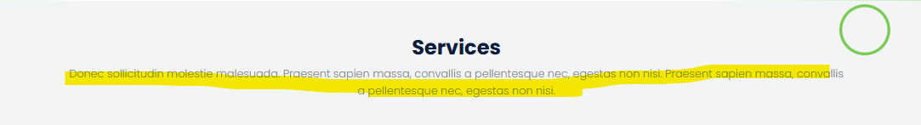

Change this to “The Team”

Remove this under “Testimonial” retain William Lee
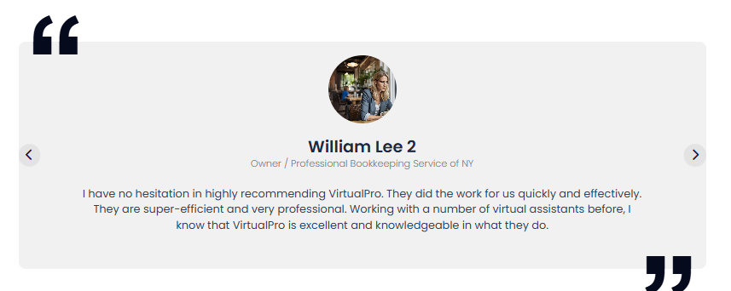

Maybe in the Hiring section, you can remove everything and add something like below.
